1. A magic square of order n is a square array containing the integers 1, 2, 3,.., n2, each one used exactly once. The value in each row, column, and diagonal must sum to the same value. As an example, the following array is a magic square of order 3.

4 3 8

9 5 1

2 7 6

Write a method to populate the square array. Each value must be different.

Write a Boolean method *isMagic* that returns true if and only if its single int [] [] parameter represents a magic square.

Other magic square:

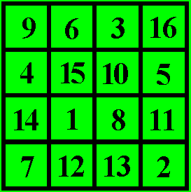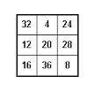

Program must repeat

Save as Magic_yourName